**AnnuaL REPORT 2017-2018**

**Office No:210, 2nd Floor, NBK Estate, Golconda Cross Roads, Musheerabad,**

**Chikkadapally, Hyderabad – 500044**

**Mobile : +91- 9989507555**

**Email :** [**nightingalesws@gmail.com**](mailto:nightingalesws@gmail.com)

**www.nightingaleindia.org**

**Nightingale Social Welfare society**

**Preface**

The year that passed by as provided some splendid opportunities to serve the mankind and realize the vision of NSWS. Since inception, it has been a professional practice for NSWS team and board members, that year after year they carry out extensive research on various social problems and scans the areas affected with these problems during its field operations, since we want to have a ubiquitous presence. Accordingly, NSWS predisposed to implement and facilitates versatile programmes, activities to improve the quality of the life styles of the people in their operational areas. With a thorough research findings and its analysis, NSWS evolves with a concrete strategy to handle a variety of issues that aim at a wide-ranged, long-term impact on social developmental activities and devised the road map to achieve the set objectives’ for the community. And this year it was not a different case.

This particular document presents the progress of activities for the annual year 2017-18, the key achievements, stake holders reached, services provided, impact created, financial status of the organization and future plans we envision for the target population.

From the bottom of our heart we profusely thank each and everyone who have in whatsoever way contributed to the progress of the activities. Firstly we would like to thank all the stakeholders without whose support we would have not been able to implement the activities successfully, to the institutional and individual donors, whose contribution year of year is commendable without their resource support we would have not gone anywhere we are. To all the team members of NSWS whose dedication and commitment reflects our own one. There relentless persuasion with unquestionable ensnared inclination to serve the society, and sharing the board members dream has made our task easier to serve the society. Our vision to confiscate un-equality and to bring about human excellence would not be possible, without the support these innumerable and valuable contributions.

**Primer:**

Nightingale Social Welfare Society (NSWS) is a not-for-profit; Indian Non-Governmental Organization (NGO) registered in the year 2005 under the Andhra Pradesh Societies Registration Act of 2001. It is a Voluntary development organization working to restore comprehensive development for the vulnerable and marginalized communities.

NSWS is formed by likeminded young professional social workers working to create high standard of living for vulnerable and marginalized communities. Executive Boards versatility is enriched through the presence of social workers, financial experts, medical professionals and local community ensuring holistic approach to cater to all kinds of social development activities for all spheres of life. NSWS firmly believes that the any desires change in the lives of underprivileged children will come only when more and more privileged people participate proactively in finding a solution to the problem.

**NSWS Vision**

We envision a society where every individual has equal opportunities with human excellence, free from all forms of discrimination, strengthening their inherent capacities to live a dignified life.

**Our Mission**

The mission of NSWS is to proactively be of service to human kind especially children, women, farmers, youth and vulnerable populations in all spheres of life focusing on holistic development of wellbeing through an inspirational and social change by helping them to help themselves.

**Core Values of NSWS**

The values that members of NSWS share and work towards a society that would:

* Fosters a sense of community
* Emphasis’ on empowerment
* Is ecologically responsible
* Strives for knowledge and equality
* Supports personal growth
* Act and interact with empathy with all the Foundation’s beneficiaries
* Promote respect, team working and initiative
* Act pragmatically, fairly and responsibly
* Believe in partnership and team work
* Function with Humility, Humanity and Integrity

**Operational areas:**

We are a nongovernmental professional social workers body aiming to serve the society with both traditional and contemporary social problems. The NSWS board members and team are always in a lookout to cater to the societal needs of the community we operate in. Moreover, we intend to contribute to the developmental indicators of the Govt. of India and aim its work to facilitate the process of achieving Millennium Development Goals. Thus, NSWS started working in urban areas of Hyderabad and rural areas of Rangareddy districts of Telangana, its administrative office located in Capital city of Telangana.

**Progress for the year 2017 - 2018**

In the pursuit to achieve our vision, NSWS has been striving hard to reach the unreached through its various programmes, this document illustrates the kind of work we have put in the financial year 2017 -18, and in a snapshot we were able to continue all the programmes implemented from the previous years with additions few additions.

True to the spirit of humanity and on par with its vision, NSWS implements and facilitates versatile programmes, activities to improve the quality of the lives of the people in their operational areas. After through situational assessment analysis with the community in the operational areas, NSWS evolve with a concrete strategy to handle a variety of issues that aim at a wide-ranged, long-term impact on social developmental activities and devised the road map to achieve the set objectives’ for the community. Few notable impact oriented programmes carried out by NSWS are:

**Residential Special Training Centre (RSTC)**

Since its inception NSWS is committed towards improving the health, education, self-esteem and image of the school dropout. Thus from 2011 it has been running a residential special training centre at Bandlaguda, Kesara Mandal for the school dropout children. With huge success in terms of bridging the education and re admitting the children into mainstream schools for their continuum of quality education.

*Title of the project* : Work site schools for Migrant Families

*Aims & Objectives* : The project objective is to abolish child labor and support

the continuum of education to the migrant children.

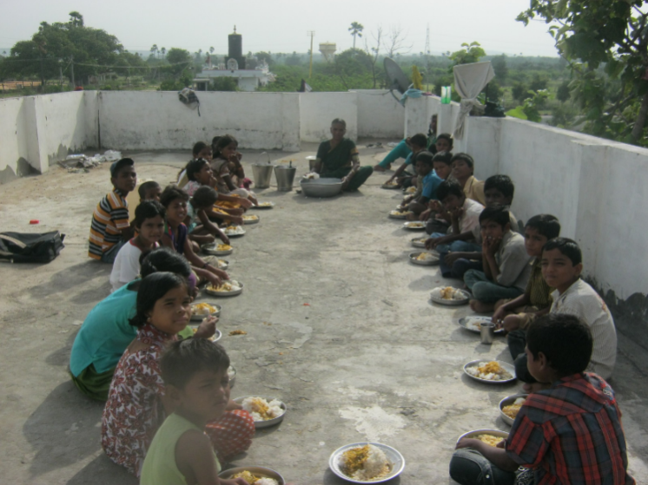

*Services Offered* :

Sarva Siksha Abhiyan (RVM) and NSWS has partnered to implement work site schools programme for the Odisha migrant people. In order to check student dropout rate among child workers in the state, RVM, is setting up worksite schools to impart training to the children with the help of NGOs in 22 districts. The government's Rajiv Vidya Mission will monitor its implementation. Worksite schools are those which function close to the sites where children work, like near brick kilns, rice mills, agriculture fields and small factories. Teachers/Volunteers recruited by the NGO would impart basic education to these children at their worksites itself. Most of the children enrolled in school were from poor Socio-Economic background, child labor, and engaged in sibling care at homes. These children are given life skill based education with excellent TLM with good food and friendly environment. The children will be mainstreamed in Govt. schools and Hostels of their convenience after the course period is over.

Nigtingale Society is addressing the education facilities for the children of migrant brick kiln workers. So far 50 worksite schools have been started in Ibrahimpatnam mandal of Rangareddy district with the coverage of 1,256 children. The children are taught in Oriya language by teachers hired from Odisha. Till date 49 Oriya teachers are hired by the NGO. The organization has been distributed slates, pencils, notebooks to the 500 children so far. Other materials like Oriya books, stationery, Teaching Learning Materials (TLM) etc. are in the pipeline. Has set a target to eliminate the child labor, the target population is of children below 14 years of age working in establishments.

**Women Empowerment**

20

NSWS firmly believes in Gender Balance and gives women upmost priority, in all its programmes women are encouraged to participate proactively. Thus in the current year conducted Women Development Programme such as Self Help Group promotion program for women. Organized awareness programme on motivation, formation and training of women SHG in rural and urban areas. The outcome of these programmes was formation of mother committees.

NSWS has provided skill development for women and facilitated trainings in Self Employment opportunities and Entrepreneurship development. Facilitated formation of women groups and as a part of this programme, arranged internal loans in the first phase. Nearly 15 groups were formed and were benefitted under different schemes and most of the groups have participated in vocational training programmes organized in Hyderabad urban slums.

**Free General Health Camps**

As a strategy of ‘HEALTH TO ALL’, NSWS with its previous years’ experience of organizing eye camps in its operational areas. In the current year based on request from the villagers and community members initiated General health camps for the below poverty line population in the areas it operates in. Under the head of this program the organization has conducted Medical Camps with the support from Ramakrishna Mission, Lions club hospitals etc., when chronic and critical patients were identified in the camps they were referred for advance treatment to the concerned hospitals. Also most of patients were linked to Rajiv Arogyasree Scheme. In the camp all the attendees were provided with general medicines free of cost, in few camps when local community members were active and they have distributed fruits and nutrition supplements for children and elder attendees.

Organized 12 medical and health camps for children, women and elder persons. During these camps wide publicity was given on the importance of balanced nutritious diet for the good health of the community members. The support of local leaders and volunteers was taken to organize these camps. Apart from this 11 Free Eye testing camps were also conducted in the operational areas.

**HIV/AIDS Mass Awareness programme through Magic Shows**

Being a responsible voluntary organization NSWS through its operational scanning identified few sensitive locations like Motinagar in Hyderabad prone to HIV/AIDS. Thus with the help of local donors have organized mid media campaign on creating general and specific awareness on HIV/AIDS targeted all types of communities. This activity was taken up in consultation with APSACS – nodal organization to prevent HIV/AIDS.

Magic shows were organized through a professional magician, through fun related tricks he made the audience realize the magnitude of the problem and educated them on preventing it. Overall these type of activities were a huge hit in people, with this type of activity could reach out to the masses and could aware them about the transmission, about the safe sex practices. Even given gifts to the people who have knowledge and responded with correct answers to the questions raised by the magician on the topic.

**Environment Awareness Programmes**

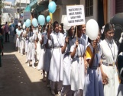NSWS was also actively involved in campaigns like Save the Earth has it profoundly believes in safeguarding the natural resources. Thus, always in its activities uses green and natural products. In this pursuit it also conducted 11 mass environment awareness programmes through mid-media activity. All the operational areas were covered educating the villagers and community members on importance of planting trees, saving water, judicious usage of water, importance of safe drinking water, sanitation, hand washing and toileting. More than 150 members in each camp has been reached, in total 1800 community members were reached through this activity. The resources for this activity were raised locally.

**Observing all key Developmental Day’s**

Another feather in the cap of NSWS is ensuring that all the key developmental day’s celebrated with precise objective involving various community leaders, concerned officers, school children, youth, villagers, women etc., The main objective of these observing or celebrations are to enhance and build the knowledge of the community members and to empower the women in our operational areas, NSWS periodically organizes various sensitization camps on various rights like domestic violence, dowry act, sexual abuse, harassment, consequences of early marriages, child rights etc., Eminent personalities and human activists would be invited to preside over these camps. This year too we have celebrated Women’s Day, Human rights Day, Blood Donation Day, Globe Day, AIDS Day and all other important developmental days. During these camps we also sensitize the women on the various schemes government is providing to women for their empowerment, SHG members are roped in to mobilize the people and also to follow up with the attended women.

**Financial Component**

The society with its core value to transparency has robust monitoring mechanisms in order to have financial controls. Since, most of its funds are from government and individual donors, the money received is spent in a very judicious manner with a concept of every penny saved is every penny earned. Moreover, its strong finance controls systems will enable that finances are properly streamlined to achieve the desired outputs. All the financial transactions are prepared by account, verified by manager and approved by the project director, only then it is disburse. Every month the Executive Board reviews the organizational progress, and during that period they also review the finance. Apart from this donors are given the status of fiancés through reports of how they are spent and what is the status of funds.

**Our vision for the future**

In line with its vision and mission, NSWS always intends to meet them religiously with the support of various stakeholders and beneficiaries. Since we intend to set new standards to ourselves and help the community to help themselves, we want to sustain the initiatives taken up during this year and want to vigorously work towards expanding them. NSWS wants to concentrate on the following activities in the next one year.

* Taking up environment safety programmes
* Skill development for the youth
* Support for the HIV infected and affected children
* Observing all the important developmental day’s
* Support to migrant children on health and education
* Raise funds through individual donors by organizing events and campaigns.
* To implement health programmes and strengthen the existing government health set up.
* To attain statutory compliances like 80G.

**Acknowledgments**

NSWS board members on behalf of the NSWS team and NSWS beneficiaries profoundly thank all the Institutional donors, Individual donors, Concerned Government officials, Visitors, Well-wishers, Media and all the people who are involved in supporting our organization in developing it as a professional one by supporting us in kind and cash. We reassure that with the support provided we see a ray of vibrant future for the society in serving the community in multifold level. We will surely be indebted for the support provided by each and all.